|  |  |
| --- | --- |
| **Name:** | Vinith Shetty |
| **Roll No:** | 55 |
| **Class/Sem:** | SE/IV |
| **Experiment No.:** | 6 |
| **Title:** | To perform program to reverse the word in string |
| **Date of Performance:** | 27/02/2024 |
| **Date of Submission:** | 05/03/2024 |
| **Marks:** |  |
| **Sign of Faculty:** |  |

**Aim:** Assembly Language Program to reverse the word in string.

**Theory:**

This program will read the string entered by the user and then reverse it. Reverse a string is the technique that reverses or changes the order of a given string so that the last character of the string becomes the first character of the string and so on.

**Algorithm:**

1. Start
2. Initialize the data segment
3. Display the message -1
4. Input the string
5. Display the message 2
6. Take characters count in DI
7. Point to the end character and read it
8. Display the character
9. Decrement the count
10. Repeat until the count is zero
11. To terminate the program using DOS interrupt
12. Initialize AH with 4ch
13. Call interrupt INT 21h
14. Stop

**Flowchart:**

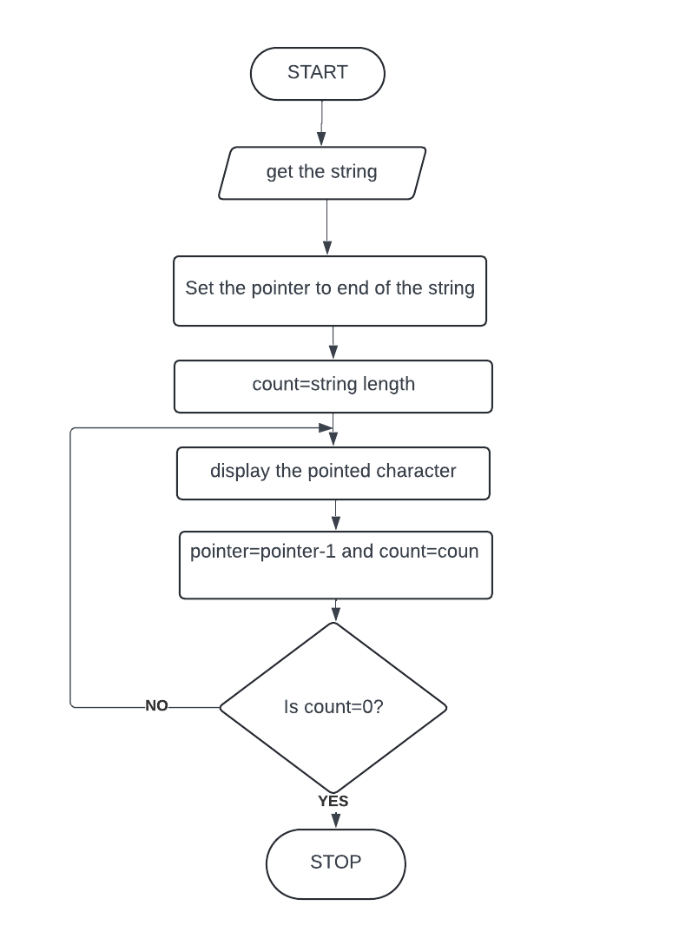

Code:

.MODEL SMALL

.STACK 100H

.DATA

; The string to be printed

STRING DB 'This is a sample string', '$'

.CODE

MAIN PROC FAR

MOV AX,@DATA

MOV DS,AX

; call reverse function

CALL REVERSE

; load address of the string

LEA DX,STRING

; output the string

; loaded in dx

MOV AH, 09H

**INT** 21H

; interrupt to **exit**

MOV AH, 4CH

**INT** 21H

MAIN ENDP

REVERSE PROC

; load the offset of

; the string

MOV SI, OFFSET STRING

; count of characters of the;

;string

MOV CX, 0H

LOOP1:

; compare **if** **this** is;

;the last character

MOV AX, [SI]

CMP AL, '$'

JE LABEL1

; **else** push it in the;

;stack

PUSH [SI]

; increment the pointer;

;and count

INC SI

INC CX

JMP LOOP1

LABEL1:

; again load the starting;

;address of the string

MOV SI, OFFSET STRING

LOOP2:

;**if** count not equal to zero

CMP CX,0

JE EXIT

; pop the top of stack

POP DX

; make dh, 0

XOR DH, DH

; put the character of the;

;reversed string

MOV [SI], DX

; increment si and;

;decrement count

INC SI

DEC CX

JMP LOOP2

EXIT:

; add $ to the end of string

MOV [SI],'$ '

RET

REVERSE ENDP

END MAIN

Output:

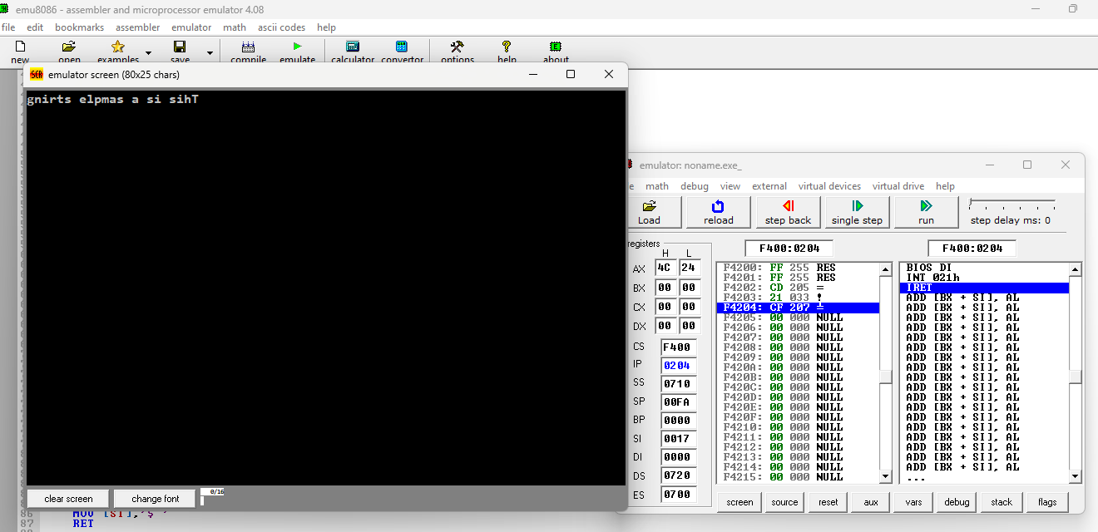

Conclusion:

1. Explain the difference between XLAT and XLATB

XLAT and XLATB are both x86 assembly language instructions used for byte translation. However, they have some differences:

1. XLAT (or XLATE):

- XLAT stands for "Translate Byte", and it is used to translate a byte in the AL register using a lookup table.

- The lookup table is pointed to by the DS:BX register pair.

- After translation, the result is stored back in the AL register.

- This instruction is primarily used for simple byte translation tasks.

2. XLATB:

- XLATB stands for "Translate Byte at DS:EBX", and it is similar to XLAT but with a different operand.

- In XLATB, the lookup table is pointed to by the DS:EBX register pair, unlike XLAT where it's pointed by DS:BX.

- The result of the translation is again stored back in the AL register.

1. Explain the instruction LAHF.

The `LAHF` instruction, which stands for Load AH from Flags, is an assembly language instruction in x86 architecture. Here's what it does:

1. Function: The `LAHF` instruction loads the contents of the flags register (EFLAGS) into the AH register. The AH register is the high byte of the AX register pair.

2. Flags Included: The flags loaded into AH are the six status flags and the two control flags. These are:

- SF (Sign Flag)

- ZF (Zero Flag)

- AF (Adjust Flag)

- PF (Parity Flag)

- CF (Carry Flag)

- OF (Overflow Flag)

- DF (Direction Flag)

- IF (Interrupt Enable Flag)

3. Format: The format of the `LAHF` instruction is simply `LAHF`, with no operands.

4. Purpose: The primary purpose of `LAHF` is to facilitate the manipulation of flags within the program. By loading the flags into a register (AH), programmers can perform various operations on them, such as testing for specific conditions or modifying them directly.

5.Usage `LAHF` is often used in conjunction with the `SAHF` (Store AH into Flags) instruction. Programmers may use `LAHF` to save the current state of the flags, perform some operations, and then restore the flags to their original state using `SAHF`.

Here's a simple example illustrating the usage of `LAHF`:

```assembly

; Example code snippet

LAHF ; Load flags into AH

PUSHF ; Push flags onto stack

...

POPF ; Restore flags from stack

```

In this example, the `LAHF` instruction loads the current state of the flags into the AH register. Then, the `PUSHF` instruction pushes the contents of the flags register onto the stack for later retrieval. After some operations, the `POPF` instruction restores the flags from the stack. This sequence allows the program to manipulate the flags while preserving their original state.